**COMP 6751 Natural Language Analysis**

**Project Report 4 (Demo)**

Student name: Md Sakib Ullah Sourav

ID: 40264066

*Expectations of originality:*

*I, Md Sakib Ullah Sourav (student id 40264066), certify that this submission is my original work and meets the Faculty’s Expectations of Originality.*

*Date: December 13, 2023*

**Contents**

Example 1 3

Example 2 5

# **Example 1**

“godfather is a wonderful film but dull story”

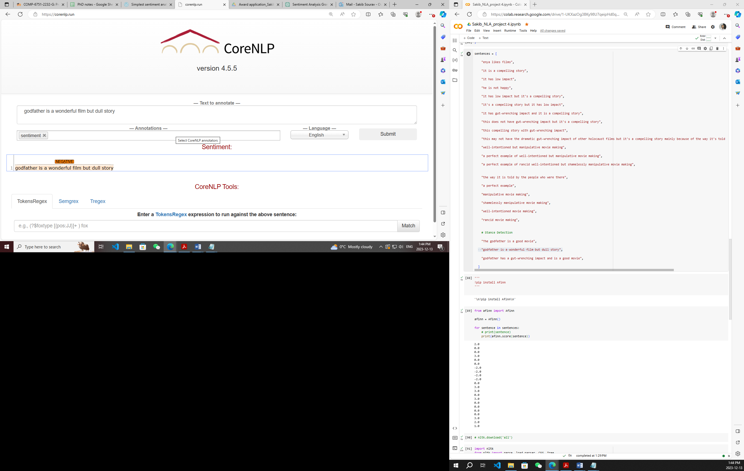

**Figure 1:** CoreNLP sentiment annotation on sentence example 1.

I consider the above sentence as a stance of the movie review. CoreNLP categorized it as a negative sentiment (Figure 1). However, if we have a closer look on the sentence we can see that though the sentence contains “dull” after the conjunction “but”, the semantic meaning of the entire comment/review refers to the film as a positive sentiment. Because the review statement might indicate the making, visuals or screenplay of the movie more rather than its story which was boring.

The interesting and great fact that the grammar I developed in this project categorized the sentiment of this sentence as positive that we can see from figure 2 and 3.

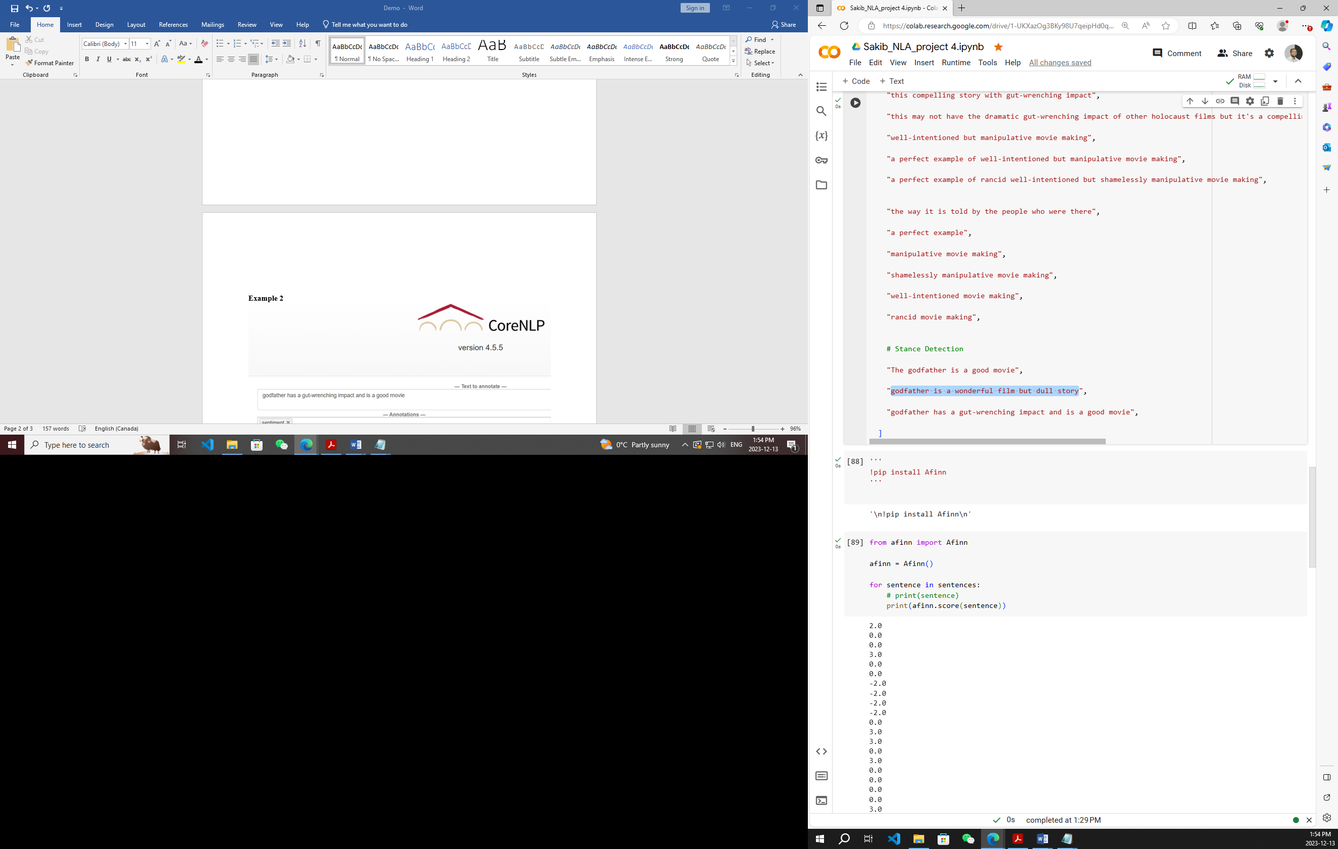

**Figure 2:** Sentence example 1 in the code[1].

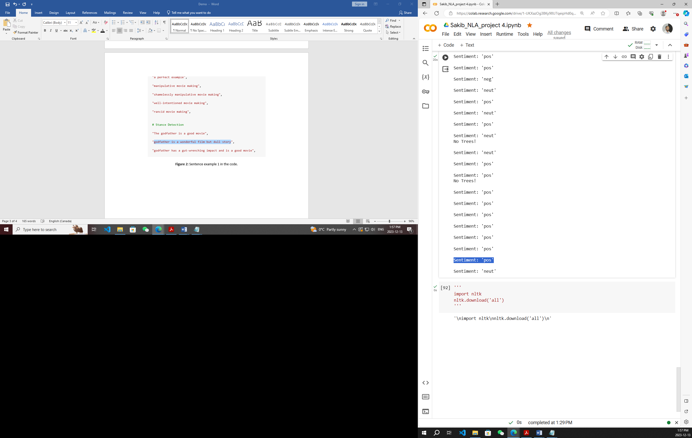

**Figure 3:** Sentiment result of my model on Sentence example 1.

# **Example 2**

"godfather has a gut-wrenching impact and is a good movie",

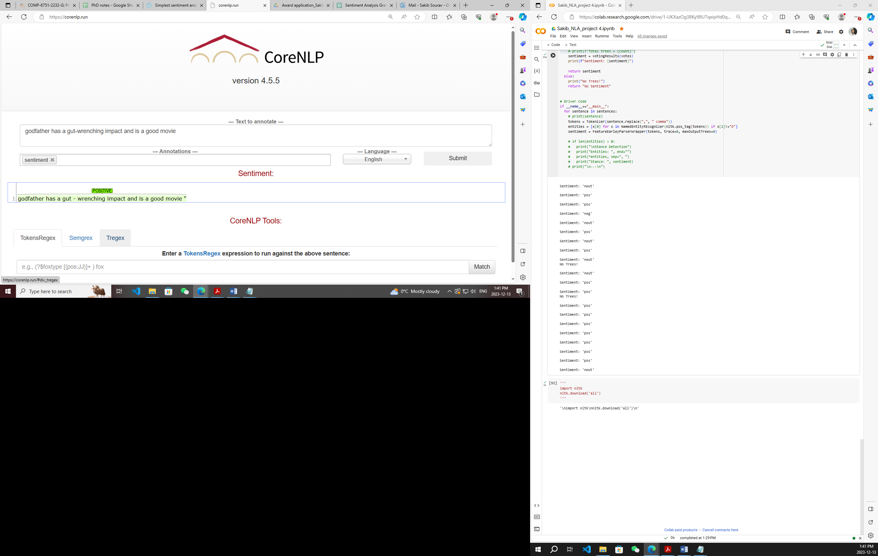

**Figure 4:** CoreNLP sentiment annotation on sentence example 2.

The above sentence was considered as another stance of the movie review. This sentence contains both negative and positive sentiments prior and after the conjunction “and”. We can consider the sentiment bearing adjective after the conjunction only. Or, as my grammar considers both the adjectives each side, we will consider the whole sentence sentiment. This way, the semantic meaning of the sentence can be interpreted as positive or neutral. None of these sentiments are wrong.

CoreNLP annotated the sentence as Positive (Figure 4), yet the grammar I developed in this project categorized the sentiment of this sentence as **Neutral** that we can see from figure 5 and 6.

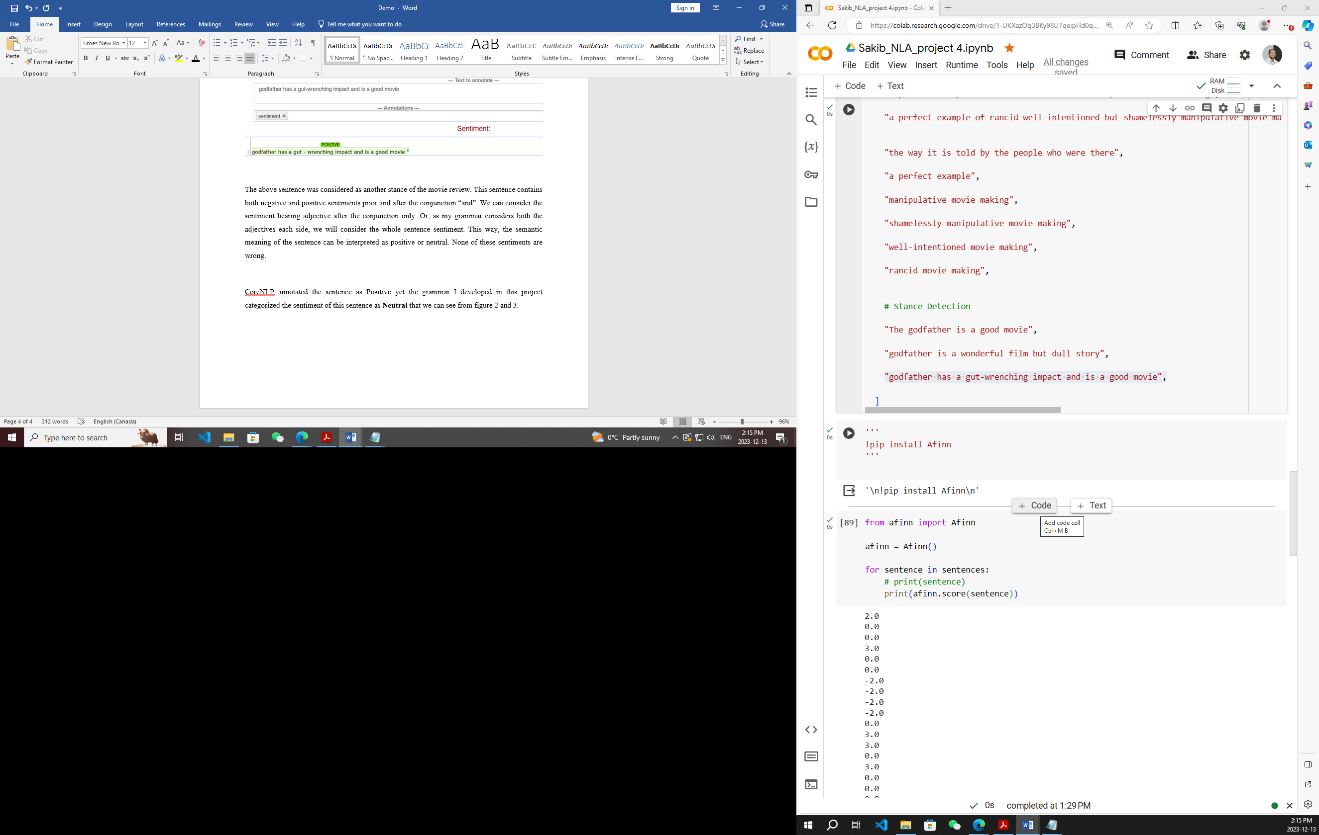

**Figure 5:** Sentence example 2 in the code.

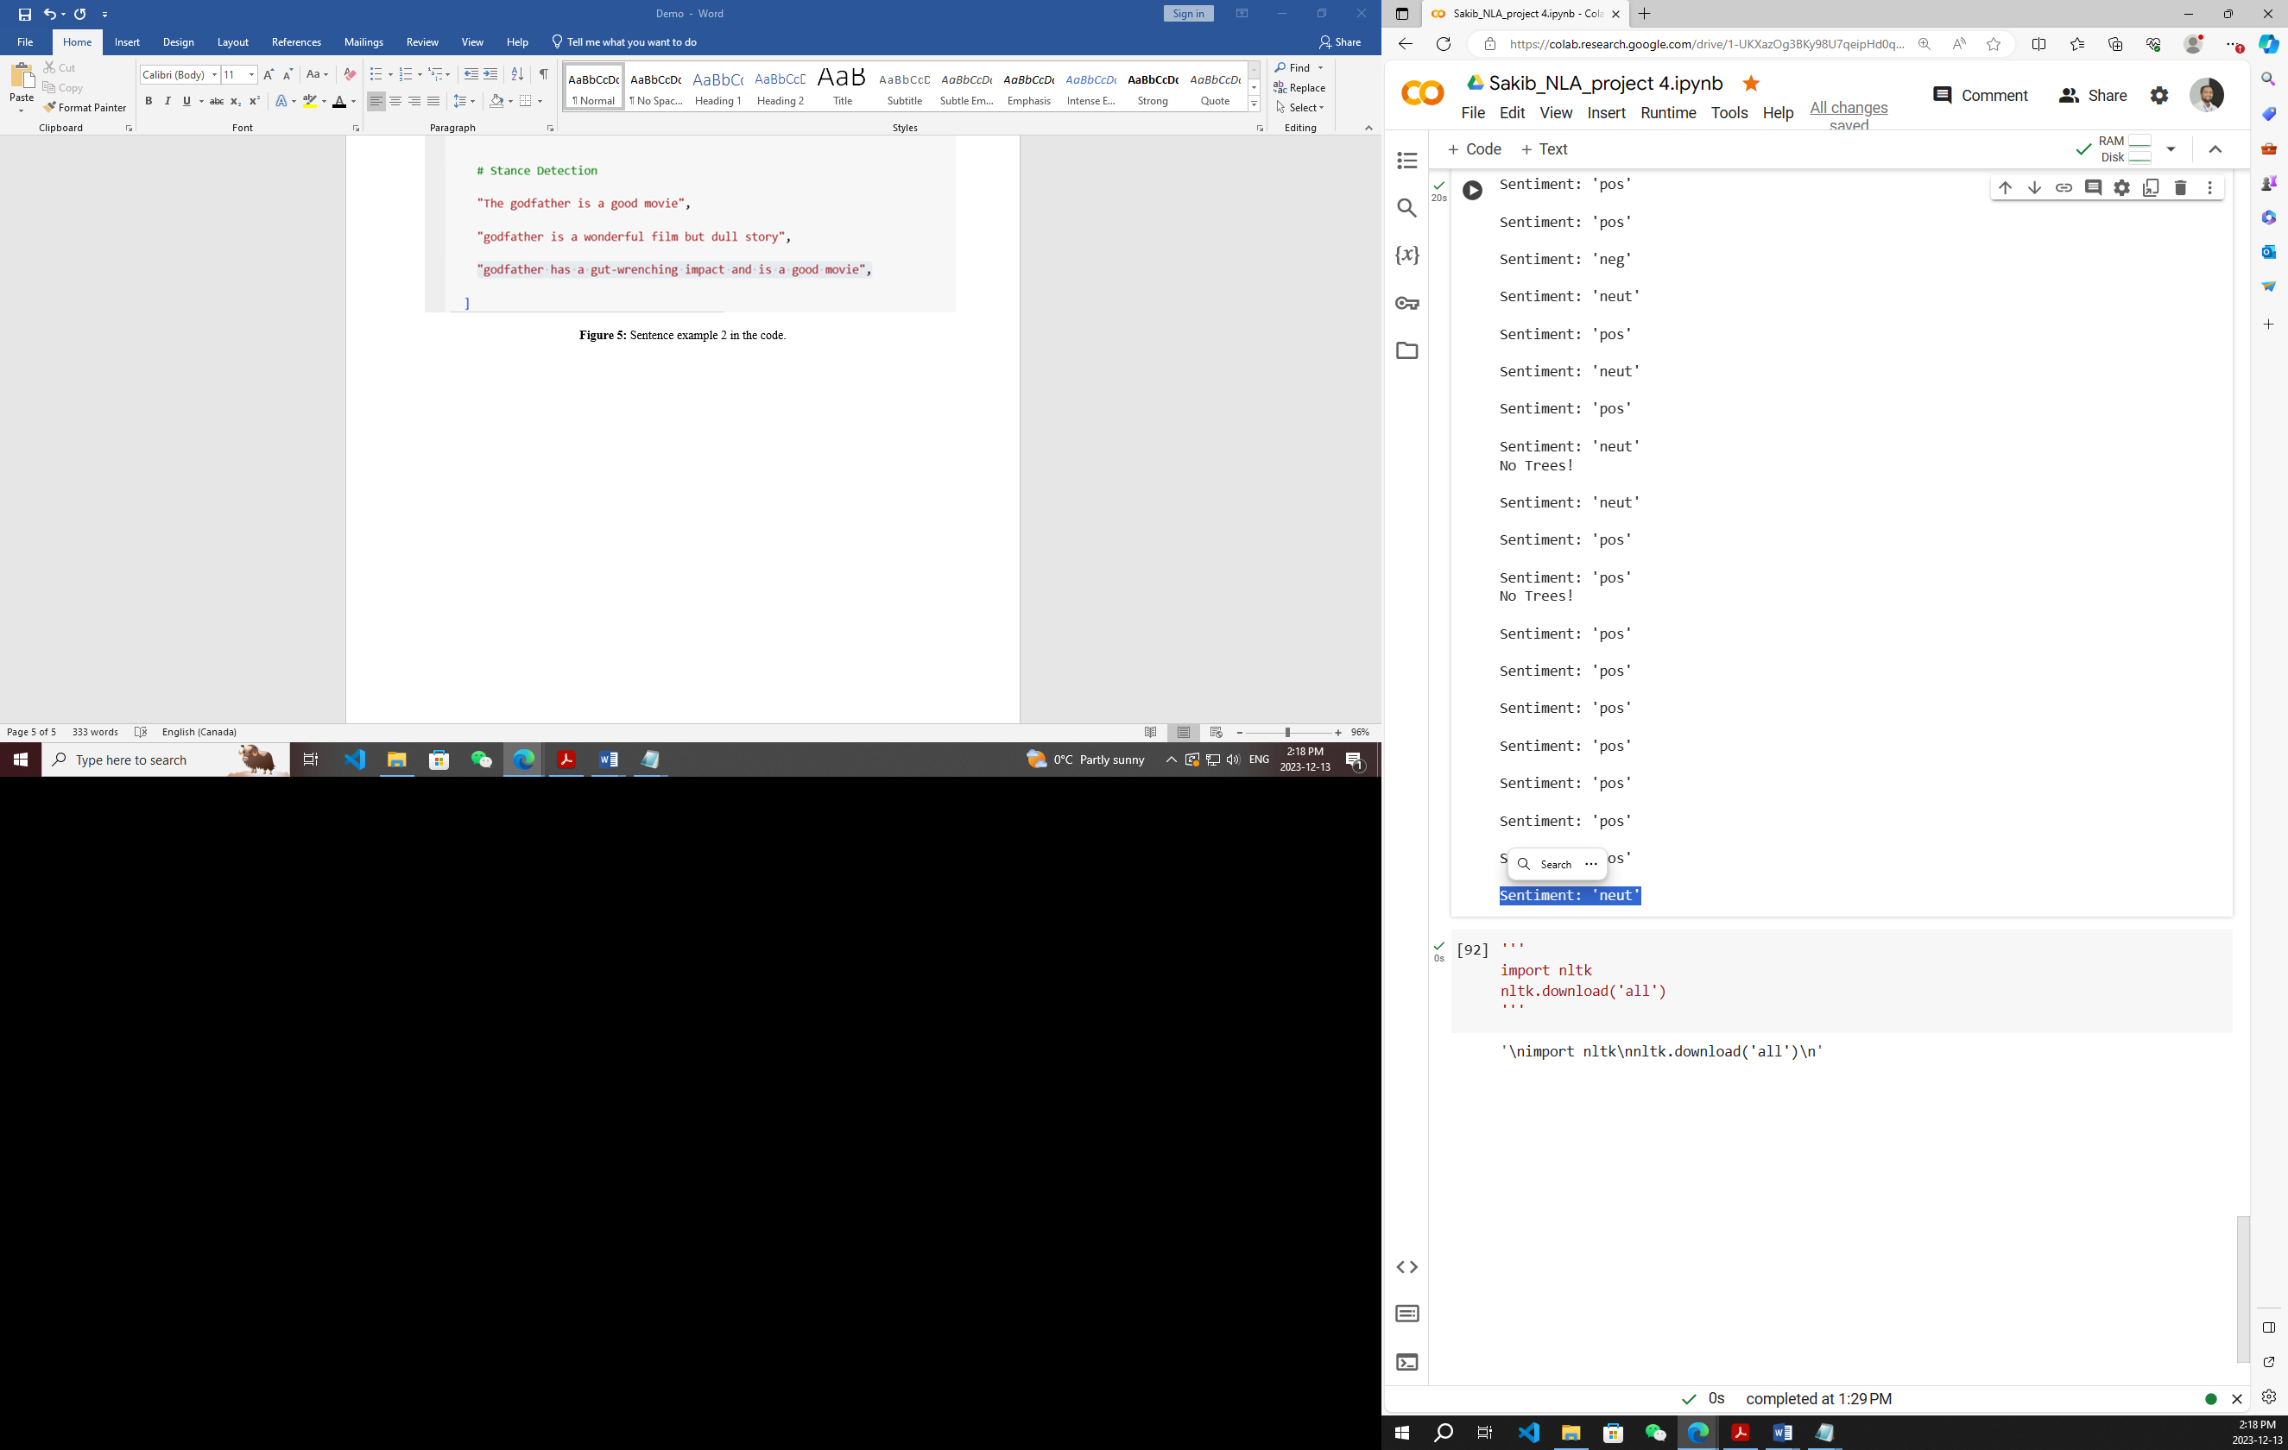

**Figure 6:** Sentiment result of my model on Sentence example 2

1. You can access to my entire code of this project here- https://colab.research.google.com/drive/1-UKXazOg3BKy98U7qeipHd0q4mi1eebn?usp=sharing